**Paper Writing Instruction for TSSP Conference**

Given Name SURNAME a, Given Name SURNAME b, Given Name SURNAME c, Given Name SURNAME d

a,b*National Graduate School of Engineering, Zzz University, Quezon City, Metro Manila, 1101, Philippines*

a*E-mail: isc1@zzzu.edu.ph*

b*E-mail: isc2@zzzu.edu.ph*

c*Graduate School of Paper Review Committee, TSSP University, Cebu City, 6000, Philippines; E-mail: prc@tsspu.edu.ph*

d*College of Transit, University of Mobility, Davao City, 8000, Philippines; E-mail: ctumd@ umdc.edu.ph*

**Abstract**: The Transportation Science Society of the Philippines or TSSP is an EASTS (Eastern Asia Society for Transportation Studies) domestic society of researchers and practitioners from the Philippines. Its primary objectives are to foster and support excellence in transportation research and practice and to stimulate professional interchanges in all aspects and modes of transportation. It organizes an annual conference on transportation studies. (max: 150 words)

*Keywords*: Transport, Asia, Academic Paper, Practical Paper, Awards (max: 6 keywords)

**1. INTRODUCTION**

Those who want to submit a paper to the Conference should be a Lifetime, Regular, Associate or Student Member of the TSSP. Any paper submitted without a member author or co-author will be reviewed but cannot be presented at the Conference and will not be included in the Proceedings and Journals, either, if the presenter is not a member of TSSP. If you are not yet a member, you are required to apply for a membership to the TSSP, which is one of the domestic societies of EASTS, and to which you (will) belong before submitting the paper.

Those who are not yet members may refer to the information on the official TSSP website: <https://ncts.upd.edu.ph/tssp/membership-form>. Meanwhile, existing TSSP members intending to submit papers are requested to update their membership by payment of annual dues up to the current year.

**2. PAPER FORMAT**

Authors are required to follow the instructions shown below. Those papers which do not meet the following requirements may be rejected.

1. Language: English (Either American English or British English is OK).
2. Paper size: A4 paper (21 cm *29 cm)
3. Margins: The margin-top is 30 mm and other margins are 25 mm, respectively. Header is 15 mm and footer is 12 mm. The first paragraph for each section/sub-section should not be indented and the subsequent paragraphs should be indented 10 mm.
4. Spacing: Papers should be single-spaced.
5. Font: The standard font type is Times New Roman and the standard font size is 12. Minimal font size in Tables/Figures is 10. Intervals of characters should follow the standard of the adopted word-processing software.
6. Maximum length: 20 pages, including figures, tables, appendices and references.
7. Lines and words: Number of lines per page and number of words per line should follow the standard of the adopted word-processing software.
8. Page number: Do not insert page numbers.
9. Header/Footer: Do not insert anything in the header and footer.

**3. STRUCTURE**

**3.1 Basic Structure**

The title of the paper should be left-aligned in bold fonts with 14 points, where the first character of each word should be capitalized. After a blank line, the list of author(s) should be placed, including name(s) of author(s), organization(s) and address(es), and e-mail address(es). Each author’s surname should be typed in capitals, and addresses should be in italic style.

Putting two blank lines, an **Abstract** must be placed with less than 150 words and three ~ six **keywords** should be given. Then, after two blank lines, the main body of the paper starts. The main body is divided in sections and (optionally) subsections. Sections must be numbered and their titles are typed in bold capitals (for example, **1. INTRODUCTION**). Subsections must be numbered using two digits and their titles are typed in bold typeface (for example, **2.1 Data Collection**). Subsections can be further subdivided using three digits and bold typeface, where only the first word of the titles should be capitalized (for example, **3.1.2 Model validation**). Two blank lines must be left before each section title with the exception of new pages and one blank line must be placed after each section title. One blank line must be left before and after each subsection title with the exception of new pages.

**ACKNOWLEDGEMENTS, APPENDICES**, and **REFERENCES** **(**title should be left-aligned in bold capitals**)** can be placed in order, if required.

**3.2 Equations, Tables and Figures**

Equations must be written preferably with the same word processor used for the rest of the text, without hand written symbols in order to be legible. Equations must be numbered sequentially with their numbers in parenthesis, right justified and indented 10 mm. Do not embed "graphically designed" equations.

 (1)

where,

 : driving experience,

*t* : time,

 : timing of providing IVTSI, and

,  : unknown parameters.

Tables must be numbered sequentially and have a reasonably explanatory title centered over the table.

Figures must be drawn using good quality graphic software; they must be numbered sequentially and have a reasonably informative title centered under the figure.

Table 1. Model estimation results

|  |  |  |  |  |
| --- | --- | --- | --- | --- |
| Independent Variables | The existing model | | The proposed model | |
| Parameter | t score | Parameter | t score |
| Constant | 0.913** | 10.982 | 1.875** | 21.445 |
| Speed change | 0.400** | 4.381 | 0.359** | 4.022 |
| Gap distance | -7.443** | -14.514 | -7.936** | -14.878 |
| Signal visibility | 0.323** | 8.305 | 0.457** | 11.595 |
| Vertical grades | -1.173** | -13.176 | -1.584** | -17.000 |
| Road surface | -1.110** | -26.888 | -0.639** | -14.922 |
| Time slot | 0.250** | 4.846 | 0.321** | 6.743 |
| Trial number | 1.902** | 9.596 | 1.605** | 8.950 |
| Driving experience | 1.328** | 8.005 | - | - |
| Provision of IVTSI | 0.096 | 2.004 | - | - |
| Utility of the IVTSI | - | - | -11.387** | -15.765 |
|  | 1.167** | 51.568 | 1.279** | 51.092 |
|  | - | - | 44.965** | 7.582 |
|  | - | - | -25.627** | -39.043 |
| Observations | 4836 | | 4836 | |
| Initial log-likelihood | –5924.732 | | –6113.117 | |
| Final log-likelihood | –4533.361 | | –4208.739 | |
| McFadden’s Rho-squared | 0.233 | | 0.310 | |

- Not relevant; ** Significant at 1% level; * Significant at 5% level.

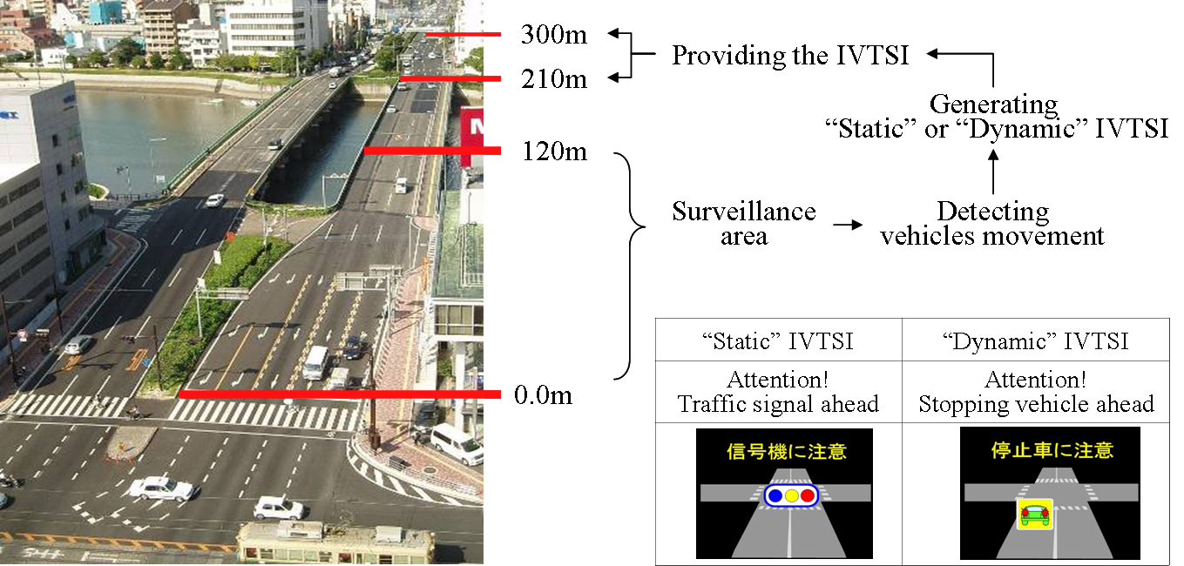

Figure 1. Procedure of IVTSI provision at an on-site driving experiment site

**4. PAPER SUBMISSION**

Following the previously mentioned paper writing instruction, authors are requested to submit a full paper as a PDF file. The requirements of submitted PDF files are “Embedding all fonts” and “Bitmapped image over 300 dpi resolution”. Do not set a password to the submitted PDF file. Never use multi-byte characters at any place of your paper including figures and tables. For example, the Chinese, the Korean and the Japanese characters should not be used. The use of such multi-byte characters may cause the file conversion problem.

The TSSP Scientific Committee may not accept papers that include any problem in files and/or characters. We recommend that authors check the file on different computers.

**5. REFERENCES**

In the body of the text papers or documents are referred by author’s surname with the year of publication in parenthesis such as Greene (1993); if the quotation is itself in parenthesis, the year of publication is separated by a comma such as (Dewan and Smith, 2003; Kockelman, 1998). If the reference has more than two authors, only the surname of the first author followed by *et al.* in italics will appear in the body of the text such as Auerbach *et al.* (1994).

To complete the paper, references must be given alphabetically by author’s surname including: surname(s) and initials of author(s), separated by a comma, year of publication in parenthesis, title of paper, *title of the journal in italic typeface*, and first and last pages. In the case of books, *the title of the book must be in italic typeface and initial capitals*; the publisher and the city of publication must be indicated.

The following examples present some of the most typical cases of references at the end of the paper; please follow them as strictly as possible.

**REFERENCES**

Wu, L., Zhang, J., Fujiwara, A., Chikaraishi, M. (2012) Analysis of tourism generation incorporating the influence of constraints based on a Scobit model. *Asian Transport Studies*, 2(1), 19-33.

Cervero, R. (2007) Transit-oriented development’s ridership bonus: A product of self-selection and public policies. *Environment and Planning A*, 39, 2068-2085.

Econometric Software (1994) *LIMDEP*. Econometric Software Inc., New York and Sydney.

Greene, W.H. (1993) *Econometric Analysis*. MacMillan, New York.

Johnson, L.W. (1990) Discrete choice analysis with ordered alternatives. In Fisher, M.M., Nijkamp, P., Papageorgiou, Y.Y. (eds.), *Spatial Choices and Processes*. North Holland, Amsterdam.

Zhang, J., Fujiwara, A., Uno, M. (2009) Is trip-making utility positive or negative? - A preliminary examination based on day reconstruction method -, Paper presented at the 12th International Conference on Travel Behaviour Research, Jaipur, Rajasthan, India, December 13-18.

European Conference of Ministers of Transport (ECMT) (1995) Urban travel and sustainable development. Organization for Economic Co-operation and Development Paris, 280pp.

Nishi, K., Kitamura, R., Kondo, K., Genma, S. (1995) Parameter estimation methods for repeated measurement data: Mass point model and mixing distribution model. *Journal of Japan Society of Civil Engineering*, 506 (IV-26), 25-33. (in Japanese)